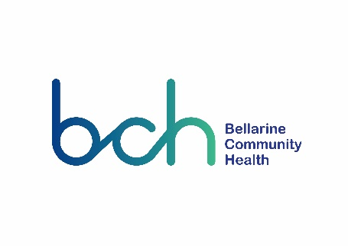

## **Brands Off our Kids! Call to Action**

Your local member is your representative in the Federal Parliament, and you’re entitled to ask him or her to represent your interests. Bellarine Community Health is inviting you to join us as we advocate for healthy environments for children in our community.

To do this, please contact your Federal Member of Parliament about the junk food marketing issues important to you and your community. It is very easy and takes no time at all! All the information you need is here:

1. **Identify your local MP**

If you’re not sure who your federal MP is, you can identify your federal member by the following website: (click on the link below) <https://theyvoteforyou.org.au/>

1. **Find your MP’s phone, email or postal details**

Find your MP through the Parliament of Australia website: [www.aph.gov.au/Senators_and_Members](http://www.aph.gov.au/Senators_and_Members)

1. **Fill in your details and send the letter below (post or email) to your Member of Parliament**

On the next page is the template letter for you to copy/paste into a new document, or write out by hand or into an email.

## **Tips for Writing Letters**

## ​

The more letters that MPs and Senators receive the more likely they are to recognise that action against junk food marketing to children is an important issue to our community. You might also consider writing to the Government Ministers and Opposition Shadow Ministers.

​

* **Include your name and address** - so that they can respond to you and they will generally pay more attention if they know you live in their electorate

​

* **Keep it brief** - tell them why you are writing at the start of the letter (e.g. I am writing to you because...).  Keep your letter short, 2 pages is good, one page is better.

​

* **Personalise the letter** - use your own words, tell your story about how junk food marketing affects you and your family.

<insert today’s date>

<insert full name of MP>

Member for <insert electorate name>

<address line 1>

<suburb> <state/territory> <postcode>

Dear <name of MP>

**Re: Brands OFF OUR KIDS! Call to Action**

I write to you today as a member of your electorate who strongly believes that the places in our community where we live, work and play should be putting health and wellbeing of our residents first wherever possible.

However, the recent [‘Brands off our kids!’ report (March 2021)](https://www.opc.org.au/downloads/brands-off-our-kids/OPC-Brands-off-our-kids-Report.pdf) released by the Obesity Policy Coalition (OPC), highlights the clever tactics that the processed food industry uses to target children with unhealthy food marketing. The report is calling on government to set higher standards and stop the industry setting its own rules.

The report sets out four actions to protect all Australian children from unhealthy food marketing:

1. Ensure TV, radio and cinemas are free from unhealthy food marketing from 6am to 9:30pm
2. Prevent unhealthy food companies from targeting children
3. Ensure public spaces and events are free from unhealthy food marketing
4. Protect children from digital marketing of unhealthy food

I am showing my strong support for the “Brands off our kids!” campaign by signing the [“Brands off our kids!” petition](https://www.opc.org.au/brands-off-our-kids#FormSystem) and am encouraging my fellow community members to join me in doing so. Our community expects government to take action to prioritise children’s health above the profits of the processed food industry. I would like to strongly urge you to also show support for these actions to protect our children from unhealthy food marketing by bringing them to the attention of Federal government.

Thank you for taking the time to attend to my letter, and I look forward to your response.

Yours sincerely,

<insert your full name & postal address / email address>